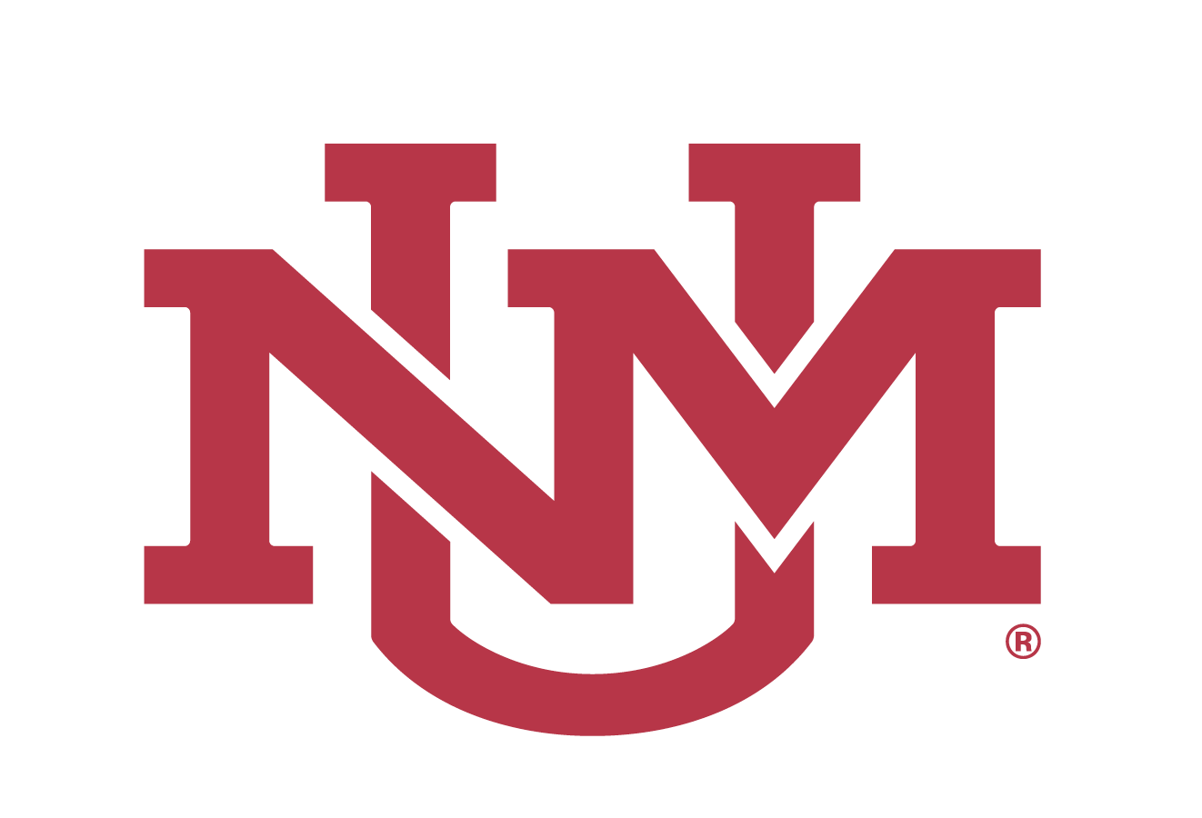
November 13, 2020

UNIVERSITY OF NEW MEXICO
BOARD OF REGENTS

NOTICE OF MEETING
Wednesday, December 9, 2020; 9:00 AM
VIRTUAL MEETING¹
Livestream: https://live.unm.edu/board-of-regents

The University of New Mexico Board of Regents will hold its next regular meeting on Wednesday, December 9, 2020, to commence at 9:00 AM. The meeting will be held virtually, via Zoom, and will be live-streamed for public viewing. To view the live-streaming, please go to the following public website: https://live.unm.edu/board-of-regents.

Public comment will be on the agenda. Due to the nature of online meetings and the logistics of getting speakers connected, anyone wishing to provide public comment during the meeting must register their intent to speak before noon on Tuesday, December 8, 2020. In order to sign up for public comment, please email regents@unm.edu with the subject “Request to provide public comment at 12/9 Regents’ Meeting”, and include the below information:

1. First name and last name
2. Email address and telephone number
3. Affiliated organization (if applicable)
4. Professional Title (if applicable)
5. Topic you would like to address

Instructions on steps to follow in order to provide public comment will be emailed to registered speakers.

In order to comply with the NM Open Meetings Act, N.M.S.A. 1978, §10-15-1(F), copies of the meeting agenda will be made available at least 72 hours prior to the meeting, accessible on the public website, https://regents.unm.edu/ .

¹Under the current guidelines from the Governor and in order to slow the spread of COVID-19, the UNM Board of Regents and Regents’ Committees will meet virtually over the Zoom platform. Meetings in open session will be livestreamed for public viewing. To view the livestream, go to the following link: https://live.unm.edu/board-of-regents

