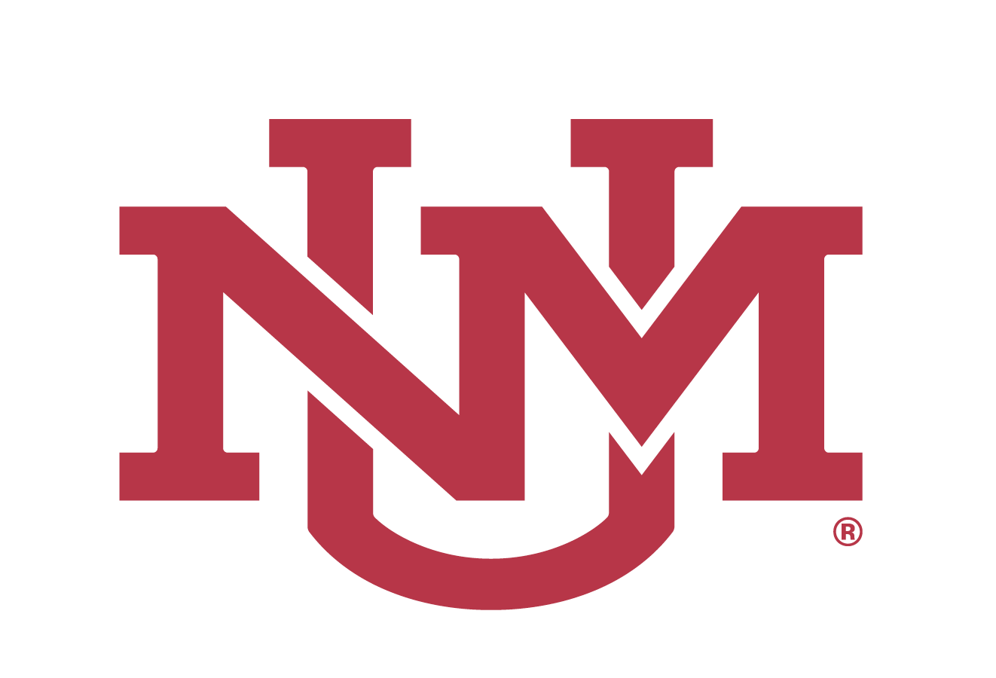

November 16, 2020

Notice of Meeting
REGENTS’ AD HOC GOVERNANCE COMMITTEE
November 30, 2020; 10:00 AM
Virtual Meeting¹
(Livestreamed: https://live.unm.edu/board-of-regents)

The Regents’ Ad Hoc Governance Committee will meet in open session on Monday, November 30, 2020 at 10:00 AM (MST).

The meeting will be held virtually on the Zoom platform and will be livestreamed for public viewing.

The agenda for the meeting will be made available at least 72 hours before the meeting.

¹Under the current guidelines from the Governor and in order to slow the spread of COVID-19, the UNM Board of Regents and Regents’ Committees will meet virtually over Zoom platform. Meetings in open session will be livestreamed for public viewing. To view the livestream, go to the following link: https://live.unm.edu/board-of-regents

